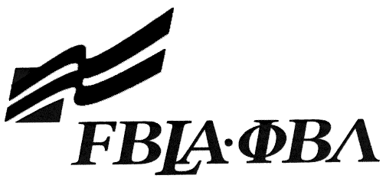 FBLA Statement of Assurance

Regional Event Entry Form
This form must be completed and attached to each copy of the media. For Internet events, complete and email this form to your regional advisor.

Check one: 3D Animation E-Business
Computer Game & Simulation Programming Mobile Application Development
Desktop Application Programming Public Service Announcement
Digital Design & Promotion Website Design
Digital Video Production

Provide the complete URL for E-business, Digital Video Production, and Website Design. These events will be judged online. Make sure the URL link is valid through the National Leadership Conference.

State: | Washington |  | Check One: FBLA
School: |  | Olympia High School
Website URL Address: (where appropriate)
Member(s) Name: |  | Sung Ahn
 |  | Andrew Hoang
 |  | Idean Labib
Local Chapter Contact
Name:
Daytime/Cell Number:
Home E-mail:

I/We, the undersigned, attest that the design, creation, and implementation of the event are the original work of the above chapter member(s). I/we agree that this event may be linked, promoted, and used in any way by the national FBLA-PBL, Inc. for purposes of promoting the association. (Typed name is accepted for signature)
Name of Team Member  Sung Ahn |  | Advisor’s Name  Skip Fabritius
Name of Team Member  Andrew Hoang |  | Name of Team Member  Idean Labib
Complete this Document Section for the Above Events (replaces Readme file):
Software Used: | Unity Game Design
Source of Information: | Website, Youtube
Copyright Notations | Copyright © 2015 SAI gaming
Instructions for Running Project: | Use the .exe file and Run it
Template(s) Used (source) | Blender Graphics Software, Crazy Bump Software, Adobe Audio, Adobe Photo Shop

